Modules and packages:
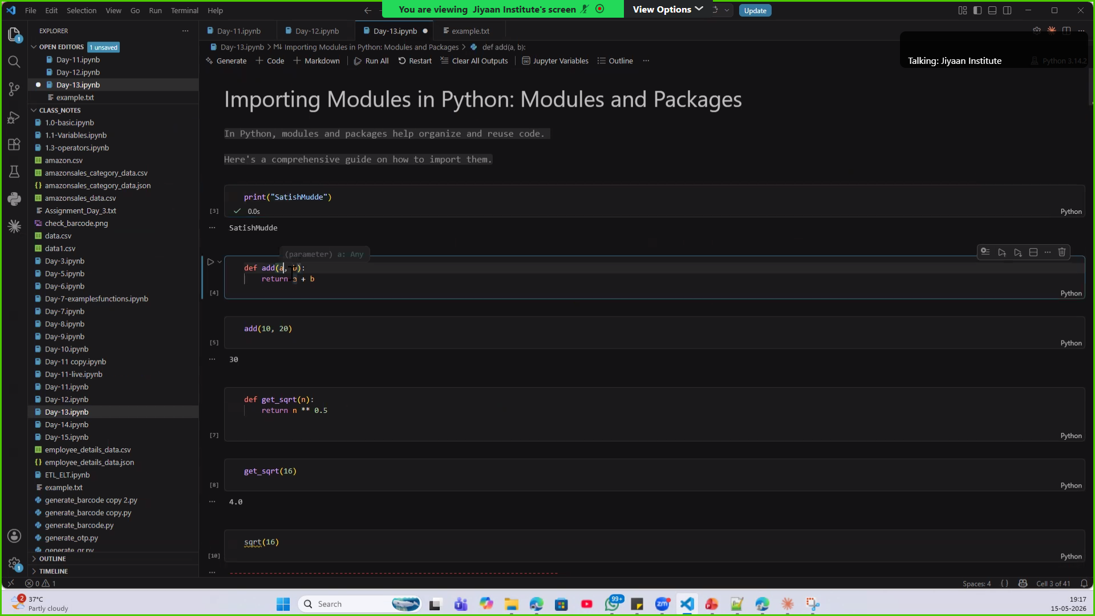
Built-in (predefined) and User defined functions

- Can be able to import required built-in modules.


